INTERNET & OPEN SOURCE

WEBSITE SPECIFICATION

ASSIGNEMENT 1

Name: Adam Hyland

Student Number: 409825

Module Title: Internet & Open Source

Module Leader: Jamie Finlay

Contents

Overview 3

Scenario 4

Scenario 1 4

Scenario 2 4

None Supported Features 5

Site Map 6

Screen by Screen Specification 7

Home Page 7

About Us 8

Contact Us 8

FAQ’s 9

Social 10

Racing Team 11

Lessons 12

Support 14

# Overview

[www.ovalskiclub.com](http://www.ovalskiclub.com) is a website provided for Oval Ski Club based in the North West. This website provides any avid skiers in the North West and the clubs customer’s easy access to any information they may require.

NOTE: This specification is not complete. The graphics and layouts of the web pages shown throughout this specification are merely in place to show the functionality of the website.

This build of the website will not have any database support not allowing users to sign in or register. Other components not supported in this build of the website can be found under None Supported Features.

# Scenario

## Scenario 1

Residents of Merseyside may be interested in going on a skiing holiday. Before they go on a skiing holiday they decide they want to learn to ski. They may use a search engine to find skiing lessons in Merseyside and come across Oval Ski Clubs website. This provides the users the chance to find out where the ski club is based and find out the pricing, dates and times of skiing lessons. The users can then choose to contact the club via e-mail, phone or using the websites personal contact form for more information regarding skiing lessons.

The User could also want more information on when Oval Ski Club has a holiday and can view pictures of past and up and coming holidays.

## Scenario 2

Laura has been a regular skier at Oval Ski Club for a few months and wants to no more about how the club is run. By using the clubs website the information on how to volunteer, the committee and the instructors can be found. Laura then decides she wants to enter the winter races that are coming up. Using the website Laura reads up on the winter’s races and fills in the online registration form to take part in the races.

A week later Laura decides to visit the website again to see when the open skiing session is and when the advanced skiing lessons are in order to improve her skiing ready for the up and coming race. By looking at the diary the necessary dates can be found for Laura to attend her next lessons.

# None Supported Features

This version of the website will not support the follow features:

* Database connection for users login
* Contact form upload connection on Contact Us page.
* Change of passwords
* Registration for users

These features are to be added at a later date.

# Site Map

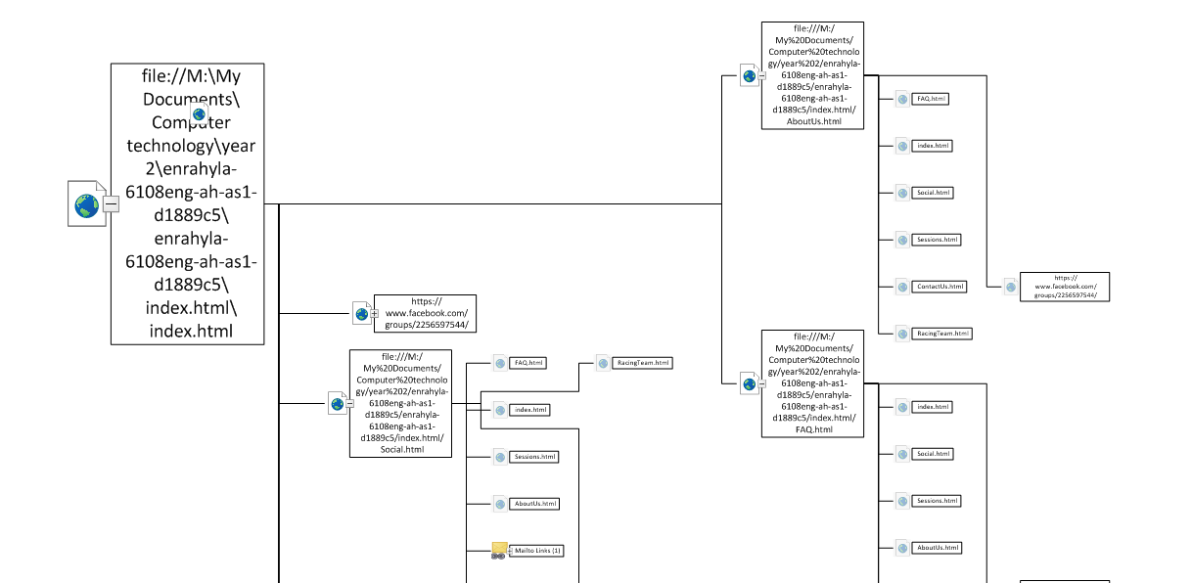

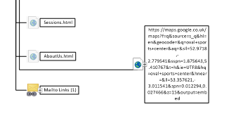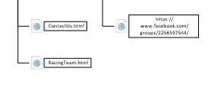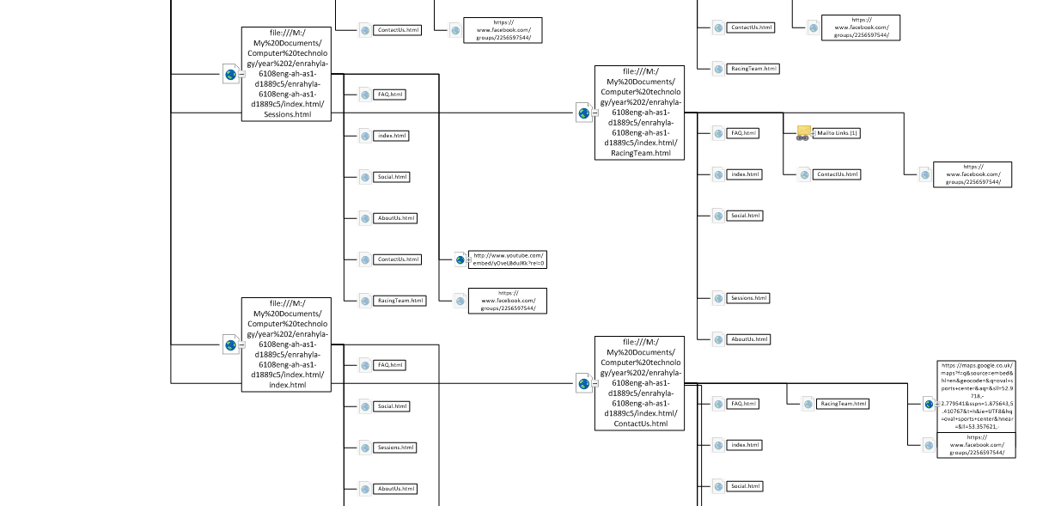

# Screen by Screen Specification

When users visit [www.ovalskiclub.com](http://www.ovalskiclub.com) they will first be greeted by the home page. This will consist of snippets of information about the club and allow users simple navigation to the rest of the website via buttons and dropdown boxes. The website consist of 6 other pages, 7 including the home page allowing users to find out information about Oval Ski Club.

The website consists of a base CSS setting the websites background image, navbar colour, text colour etc… this is consistent throughout every page of the website ensuring that the website have a uniform layout. Each page will have a hero unit at the top of the page telling the user what page they are on. The only page exempt from this is the Social page will have a carousel of images as part of the hero unit. A break down of each page can be found below.

This website was created using the “Twitter Bootstrap” framework. This consists of HTML, jquery and Javascript. This can be found at <http://twitter.github.com/bootstrap/> .

## Home Page

The Home Page is the first page presented to the users upon visiting the website. The Home page will always have its own link in the navbar of every page. Each dropdown will consist of other pages of the website. The home page serves the purpose of:

* Allowing user easy navigation to the rest of the website
* Allowing Users to Sign In using the drop down login form.
* Give users basic information about the Oval Ski Club and other activities surrounding the club.

The layout of the home page is as below:

Dropdown 1

Dropdown 2

Sign In

Home

Oval Ski Club

Footer & Facebook Link

Button

Button

Button

Text

Text

Text

Button

Hero Unit

Text

## About Us

The About us page will give users information regarding the club. There will be two tables present listing the committee members and the instructors. The About us page will be part of the ‘Dropdown 1’. The About Us page serves the purpose of:

* Allowing users easy navigation to rest of website
* Providing users with information about Oval Ski Club.
* Allowing Users to Sign In using the drop down login form.

The Layout of the About Us page is as below:

Sign In

Dropdown 2

Dropdown 1

Home

Oval Ski Club

Footer & Facebook Link

Hero Unit

Text

Table 1

Table 2

## Contact Us

The contact us page will provide users with information on how to contact Oval Ski Club and the location. The Contact Us page will be part of the ‘Dropdown1’. The Contact Us page serves the purpose of:

* Allowing users easy navigation to rest of website
* Providing users with information on how to contact Oval Ski Club. This includes:
  + E-mail link
  + Google Map.
  + Modal pop up contact form.
* Allowing Users to Sign In using the drop down login form

The Layout of the Contact Us page can be found on the next page:

Sign In

Dropdown 2

Dropdown 1

Home

Oval Ski Club

Hero Unit

Text

Text

Text

Text – Includes E-mail link

Button- brings up modal

Google Map

Footer & Facebook Link

## FAQ’s

The frequently asked questions age will provide answers to the most common asked question at the club. The FAQ’s is the last available page link at the bottom of the ‘dropdown1’. The FAQ’s page serves the purpose of:

* Allowing users easy navigation to the rest of the website
* Providing users with answers to questions most commonly asked using a collapsible form.
* Allow users to sign in via the drop down login form.

The layout of the FAQ’s page can be found on the next page.

Sign In

Dropdown 2

Dropdown 1

Home

Oval Ski Club

Hero Unit

Text

Collapsible questions and answers

Footer & Facebook Link

## Social

The social page provides user’s information about up and coming events and past events such as the walk to Hilbre Island and the club holiday. The social page will be the first link in the ‘Dropdown 2’ box. The Social page serves the purpose of:

* Providing users with images of past events and up and coming events using a carousel in the hero unit of the page. This includes:
  + Holiday prices
  + Holiday weather
  + Contact forms for holiday
* Providing users with information regarding up and coming social events and past events.
* Allowing users ease of access to the rest of the website.
* Allowing users to sign in using the drop down login form.

The layout of the Social page can be found on the next page.

Sign In

Dropdown 2

Dropdown 1

Home

Oval Ski Club

Hero Unit

Image Carousel

Text – Includes E-mail link

Text

Image

Image

Image

Text

Table

Table

Table

Footer & Facebook Link

## Racing Team

The Racing Team page provides users information on the races attended by Oval Ski Club. The racing team can be navigated to via a link in the ‘dropdown 2’. The Racing Team page serves the purpose of:

* Giving users information on up and coming races.
* Allowing users to sign up for races using links to the online entry forms.
* Allowing users easy access to the rest of the website.
* Allowing users to sign in using the dropdown login form.

The layout of the Racing Team page can be found on the next page:

Sign In

Dropdown 2

Dropdown 1

Home

Oval Ski Club

Hero Unit

Image Carousel

Image

Text – Includes links to online entry form.

Footer & Facebook Link

## Lessons

The Lessons Page provides users with information and dates of when lessons start. It will also provide users with membership fee prices. The Lessons Page is the last available link in the ‘Dropdown 2’. The Lessons Page serves the purpose of:

* Providing users with information on the prices of a membership.
* Providing users with dates and times of lessons using a diary.
* Allowing users easy navigation around the rest of the website.
* Allowing users to sign in via the dropdown login form.

The layout for the Lessons Page can be found on the next page.

Sign In

Dropdown 2

Dropdown 1

Home

Oval Ski Club

Hero Unit

Text

Text – Diary of dates and times will be scrollable.

Text

YouTube Video

Footer & Facebook Link

# Support

Any bugs on this website that may be found can be rectified at a later date. The website can be kept up to date with the latest information or can be changed if needed. All pages on the website can be kept updated with the latest information when needed.